Senior Capstone Project: Foil Bearing Test Rig
As part of the final year for engineering students at Embry-Riddle, all seniors in the program must complete a Capstone project. These projects are two semesters long and consist of preliminary design in the first semester and detailed design in the second. As an undergraduate student, they are an excellent way to tackle real-world engineering problems in a way that resembles what soon-to-be graduates will experience in industry. Capstone projects are completed in groups ranging between 5 and 8 students.
During the preliminary design phase, students are tasked with developing project requirements, performing trade studies, and delivering preliminary designs of their project. Although some teams must come up with their own ideas for capstone projects, my team has been fortunate enough to receive a sponsorship from Honeywell Aerospace. We are tasked with creating a rig to test foil bearings for use in their engines. The goal of the rig is to help engineers at Honeywell estimate the lifespan of the bearings before repair or replacement.
To give some basic background on the project, foil bearings are contactless while spinning, and rely on a thin film of high-pressure air to keep the shaft suspended and constrained. Surrounding the shaft is a series of foils, which are thin metal sheets bent into various shapes depending on the application. One of these is known as the bump foil, which acts as a spring, absorbing small impacts from the shaft and also allowing the gap between foils and shaft to change with changing film air pressure. The other foil is called the top foil and it acts as a surface for which the pressure to act upon. Given ingestion of small, high velocity dust particles over time, these foils and their coatings will abrade and eventually need replacement. As mentioned, our project is concerned with finding out how long the foils will last before requiring such replacement.
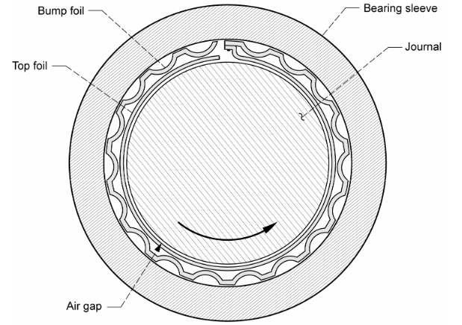
Diagram of a Basic Foil Bearing
(source: nasa.gov)
We were given a document from Honeywell detailing the “why” of this test rig and given basic requirements. Throughout the course of our meetings with our engineering contact at Honeywell, we have ascertained more about what the company requires of the machine and have developed a comprehensive set of high-level stakeholder requirements for the project.
Given these high-level requirements, we created a block diagram of the system which included the main subsystems and how each of them will interface with each other. I then created several mathematical models in Matlab to validate whether our initial layout and assumptions would work. These include a heat transfer model for air heater sizing, a fluids model to determine torque required to maintain our target speed, and so on. We use the outcomes of these models to size components, determine electrical power required for our facilities team, and to refine our initial assumptions.
With a basic system layout established, we then conducted trade studies on various components required for the project. These include components like seals, motors, heaters, controllers, and much more! The goal of these trade studies is to further refine our system based on several criteria including cost, safety, reliability, and ability to meet project requirements. While we conducted trade studies, I took some time to create our first CAD model of the test rig. While the design has not changed drastically since then, there were certain downfalls that we needed to address. Some of these were uncovered through CFD and vibrational analysis but other issues were brought up while presenting to our engineering professors and our advisor at Honeywell.
With our test rig designed and refined, components picked out, and math to validate that it should all work, we were given the go ahead to start bringing the machine to life. This brings us to the detailed design semester. I have been living in the machine shop producing part after part for the project. Simultaneously the rest of my team has been sourcing our off-the-shelf supplies, ensuring campus facilities can supply power and air to our testing location, and further tweaking the design as we discover new information.
That said, I’d like to walk you through how the test rig works. The diagram below provides a basic overview with our main subsystems labeled.
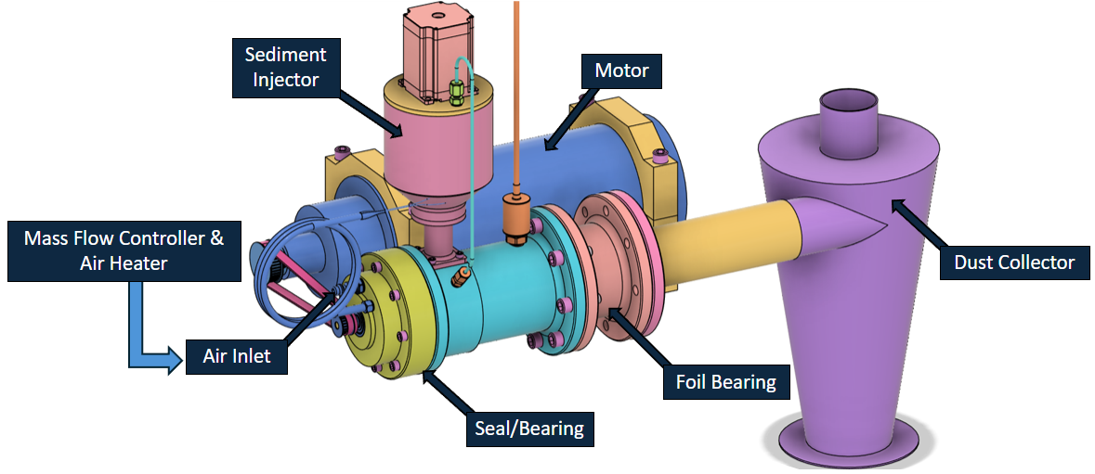
System Overview
(source: ERAU B.E.A.R Captone Team)
Prior to entering the test rig, the air from our compressor passes through a mass flow controller. This ensures that we meet our mass flow requirement given to us by Honeywell. It then passes through a computerized heater and brought up to our target temperature. Finally, the air enters the test rig through the air inlet labeled towards the left of the diagram. It flows towards the right and intersects the inlet of the sediment injector. The job of the sediment injector is to seed the air with a precisely controlled amount of dust. To determine the right amount to inject, we are simulating the worst conditions one of Honeywell’s engines will see in its regular operations, then multiplying it by an acceleration factor to speed up testing. The air and dust mixture then flows towards the back of the rig where it passes through the foil bearing and ultimately into the dust collection system. For a better look at what’s happening inside the rig, see the following cross-sectional diagram.
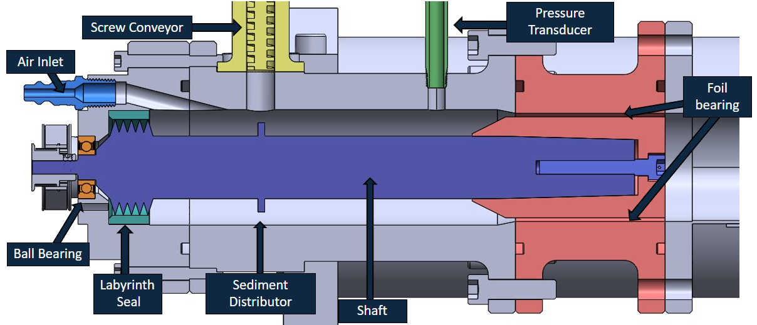
Cross-section overview
(source: ERAU B.E.A.R Captone Team)
In the above diagram, you can clearly see the air inlet in the top left corner. What you will now notice is the ball bearing and labyrinth seal directly below it now. The ball bearing supports the shaft on one end while the foil bearing supports it on the other. The purpose of the labyrinth seal is to prevent air from flowing out of the left side of the rig, rather forcing it to exit through the foil bearing side. The shaft, labeled in blue, is driven by a 7.5-kilowatt electric motor up to a target speed of 60,000 rpm through the use of a belt drive system. The sediment distributors shown were designed with the intent of spreading the dirt more uniformly as to not wear the bearing down unevenly. However, they have since been redesigned as a result of our findings using computational fluid dynamics (CFD) simulations of our system.
As of now, we have machined eight of our custom components with seven still remaining. We are on track to be finished machining by the end of February which is when we will begin assembly and integration of all of our systems. I will update the post as we make further progress.
I would like to give a special thanks to Honeywell for sponsoring our project, as well as our advisor at Honeywell and the various professors at Embry-Riddle who have guided us throughout this project. Thank you for reading and be sure to check back for future updates!

